User Manual

Project Title: Detecting brigading on social media with machine learning
Student Name: Adam Pegman
Student ID: 14351741
Stream: CASE4
Project Supervisor Name: Ray Walshe

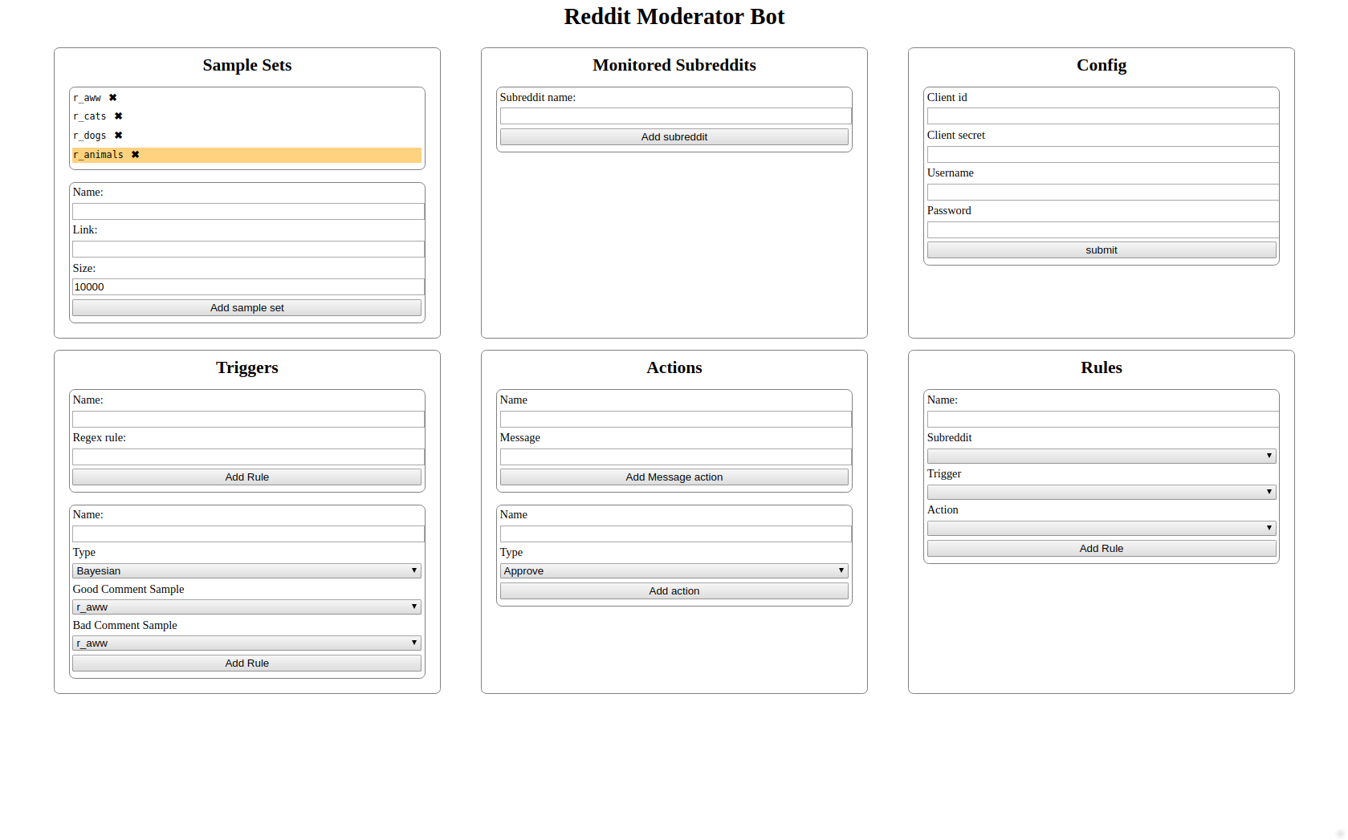

This is the user guide for a Reddit moderation bot. The goal of the bot is to replace Automoderator, the current bot used by Subreddit moderators to help moderate their subreddits. The service can watch a subreddit and apply rules, which can be triggered by regex or by using machine learning to compare them against collected samples. The service is designed to run locally on the moderator’s machine.

Installation

The service is provided as a jar file. When this jar file is run, the service creates a database and starts running on http://localhost:8080/ Visit this page to continue configuring.
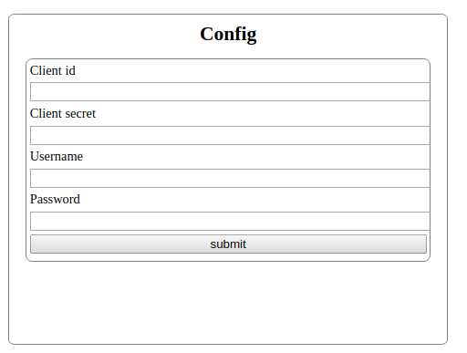

The first step of configuring the service is to create a Reddit account with permission to moderate your Subreddit. Once this is done, you can obtain a client_id and client_secret from https://www.reddit.com/prefs/apps and enter them into the config form to bind the bot to your subreddit, then pressing the submit button.

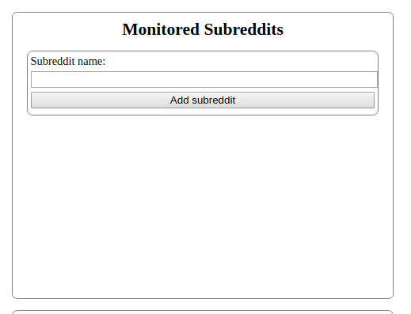

The next step is to add your subreddit to the list of watched subreddits for the service. This can be done by pasting a link to your subreddit or “/r/[name]” into the monitored subreddits form and clicking submit. The name of your Subreddit should appear in the list above, along with delete button that can be used to remove it.

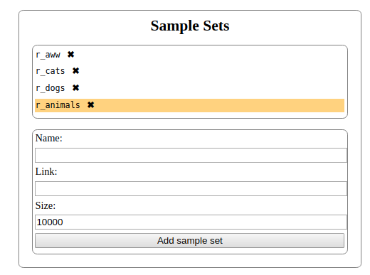

The service uses samples of comments from subreddits or threads to trigger it’s rules. You can gather samples of desirable and undesirable comments to use in your rules by entering a name, a link to the comments on Reddit and the number of comments you want to collect, then pussing the “Add sample set” button. The sample set will initially appear orange until the service finishes collecting the comments and calculating statistics about them.

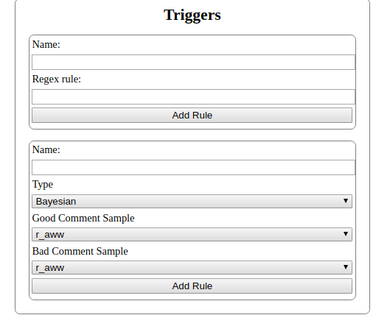

Triggers are used by the service to decide when a rule should be run.
Regex triggers use the same regular expressiions Automod uses to detect comments.
The other available triggers are:
- The Baysian trigger service, which requires a good set and a bad set, and classifies a comment as good or bad based on the words in the comment.
- The Similarity trigger, which takes a good set and a spam set, triggers if 2 of the 3 nearest comments by word counts are spam.
- The
- The All trigger, which triggers on every comment.

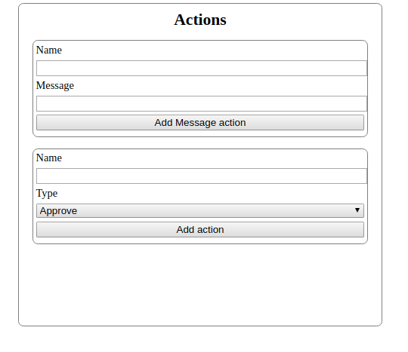

Actions are the actions taken by the service when a rule is triggered.
The available actions are:
- Posting a message replying to the comment.
- Removing the comment.
- Banning the user who posted the comment.
- Approving the comment.

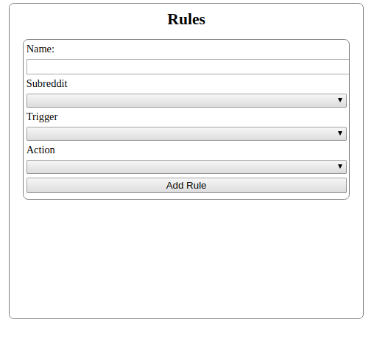
A rule is a Trigger, and an Action that should be triggered by it, as well as a Subreddit the rule should be applied to. This form should be filled out last. Rules should appear in a list above the form once created and can be deleted via the delete button.

